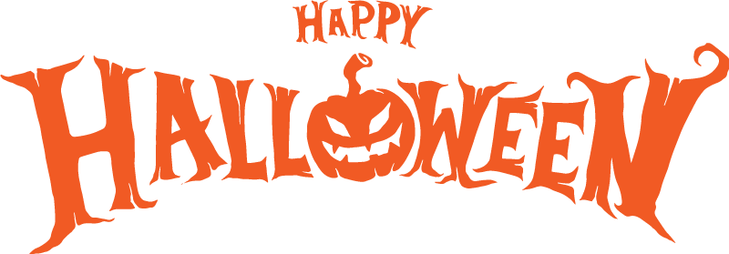
Halloween WebQuest

Directions: Answer the questions in complete sentences. Change the font color of your answers.

1. What is the ancient origin of Halloween?

http://www.history.com/topics/halloween

2. Who began the tradition of trick or treating on Halloween and why?

http://holidayinsights.com/halloween/facts.htm

3. What are the most frightful places to spend Halloween?

http://www.washingtonpost.com/lifestyle/kidspsot/fun-halloweenfacts/2011/10/18/gIQAdo7AAM_story.html

4. How is Halloween celebrated in other countries? Explain the tradition of three countries (not the U.S).

http://www.pumpkinpatchesandmore.org/halloweenglobal.php

5. What is the legend of Stingy Jack and how does this relate to the use of Jack O Lanterns on Halloween?
http://www.history.com/topics/jack-olantern-history

6. How many pounds of candy are sold annually on Halloween? http://www.history.com/topics/jack-olanternhistory/interactives/halloween-by-the-numbers

7. When did Halloween first come to America?
http://www.history.com/topics/halloween

8. Type in 5 interesting facts about Halloween that have not already been addressed in the questions above.

